Mathematics Methods Unit 3, 2022

Name: _____________________________

Date Due: __________________________

**Investigation: Volume of Swimming Pools.**

Applying area under and between curves.



This investigation is an individual, take home task of 2 weeks in duration.

By ticking this box, I am verifying that the work that is submitted is my **own**.

Signed: ___________________________ Date: ____________________

**PART A: Developing methods for calculating volume.**

Below is a rectangular prism shaped swimming pool. The pool has a uniform depth of 1.2 metres.

A Cartesian plane has been placed over the surface of the pool where the origin has been positioned on the front left corner. All coordinates given are in metres.

Not drawn to scale

<EFOFEX>
id:fxd{ad03579b-ca0f-4844-aafa-dc0cd10ac0d6}

FXData:
</EFOFEX>

**Task 1**

Using volume formulas, calculate the:

a) volume of the pool in m3.

b) capacity of the pool in litres.

**Task 2**

Show how a definite integral could be used to calculate the volume of this swimming pool. Verify that your definite integral works by way of its calculation.

Below is a second swimming pool designed to have a variable depth, changing from 1.2 metres to 1.8 metres in depth after 4 metres from the left-hand wall of the pool.

Not drawn to scale

<EFOFEX>
id:fxd{9e66b94c-27ff-401d-b29b-dcd88d163205}

FXData:

</EFOFEX>

**Task 3**

Using volume formulas, calculate the:

a) volume of the pool in m3.

b) capacity of the pool in litres.

The diagram below shows the second swimming pool again, however, a vertical “-axis” has been added to help map the depth of the pool in terms of .

Not drawn to scale

<EFOFEX>
id:fxd{194c7b86-07cc-4389-bc2f-72bac6a05344}

FXData:

</EFOFEX>

**Task 4**

Determine a **piecewise** function, , for the depth of the pool in terms of . Take as always positive, that is, for all (see **Appendix 1** for hints on how to formulate a piecewise function).

Not drawn to scale

<EFOFEX>
id:fxd{361aba5b-946b-4672-ae69-e7e2d9770a72}

FXData:

</EFOFEX>

The area trapped between a curve, , and the -axis, where , can be determined by summing the areas of infinitesimally thin rectangular strips taken between the bounds of the area in question.

In the diagram above, the area trapped between a curve, , and the -axis defines the surface area of the water in the pool.

The diagram above shows one thinslice of **volume** taken from the pool as the cross-section of the pool for a particular value of . (*Infinitesimally thin slice as* ).

**Task 5**

Show how definite integral(s) could be used to calculate the volume of this swimming pool. Verify that your definite integral(s) works by way of its calculation and compare your result to your answer to Task 3.

**PART B: Mathematically design your own swimming pool.**

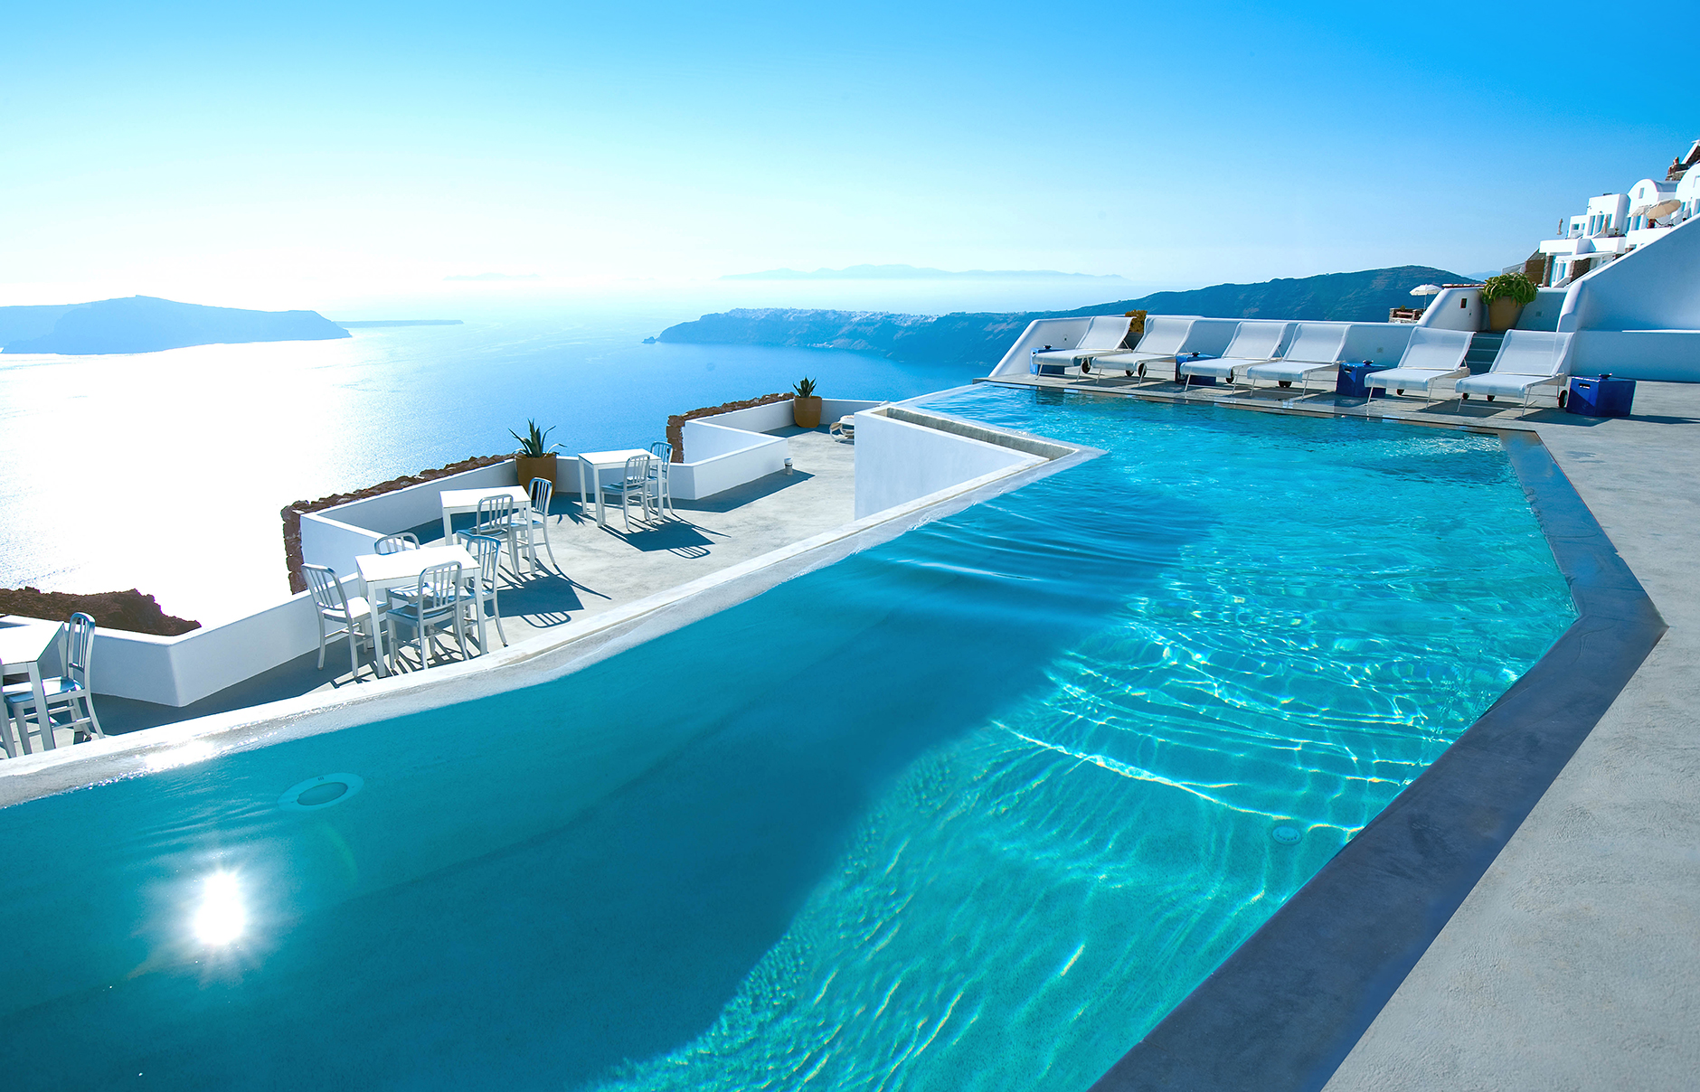A new hotel contracts you to design a large swimming pool for their customers to enjoy.

The following tasks are to be completed on the pages that follow and/or your own supply of paper.

**Task 6**

You are to design a swimming pool using the following guidelines.

* The pool is to be approximately 60 metres in length (parallel to -axis).
* The pool is to be approximately 30 metres wide (parallel to -axis).
* The pool is to be at most 3 metres deep.
* Use mathematically defined functions to map its perimeter (see **Appendix 2** for hints on how to formulate polynomial functions)
* Use mathematically defined functions to map its depth.
* The pool should be functional with a consideration to its aesthetics.

You are required to sketch your pool design using either the supplied template (back page) or using your own paper supply. You can use digital technologies to help plot your pool design. Some free graphing software include: GeoGebra and Desmos.

Clearly list all functions used and over what specific domains.

**Task 7**

Calculate the volume and capacity of water in your pool using definite integration methods. You **must show the working out** of your definite integrals and **not** rely in CAS calculators for the calculations.

**Task 8**

List any limitations to the possible design you encountered in designing your pool with regard to formulating a method using definite integrals for calculating its volume (or capacity).

**Appendix 1**

A piecewise function is a function built from pieces of different functions and each piece is defined over nonoverlapping domains.

Example.

The following function is continuous over the domain and is defined by two functions, one being linear and the other quadratic.

<EFOFEX>
id:fxd{8fc9bdc1-d979-4be8-b970-af7f8d638f16}

FXData:
</EFOFEX>

This piecewise function can be defined in the following way.

List of different functions. Domains each different function is defined over.

**Appendix 2**

**Formulating Polynomial Functions from Given Points.**

Consider you wish to define a polynomial function that approximates the curve sketched below.

<EFOFEX>

id:fxd{1087b426-f746-45b0-a5f3-c0c0bca77546}


FXData:


</EFOFEX>

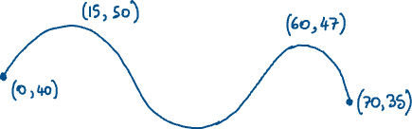

Looking at the above curve, having three turning points suggests a polynomial of degree 4 may approximate it.

That is:

To determine the values for the coefficients and constant , five known points on the curve are required. From the five points, a system of five equations will be formed.

However, using the point

The other four equations would be:

Using

Using

Using

Using

CAS can help with the solving of the system of equations.



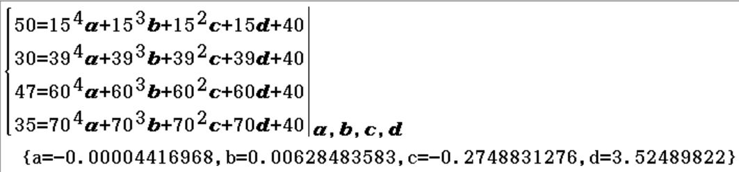

Taking the solved coefficients to 4 significant figures and plotting:

we obtain an approximation of the desired curve below.

<EFOFEX>
id:fxd{623b160f-b88a-4e5b-8f5e-fb1737ecf6a2}

FXData:

</EFOFEX>

Design template.

<EFOFEX>
id:fxd{0303efec-3a92-4325-93de-76f5d1576dc6}

FXData:

</EFOFEX>